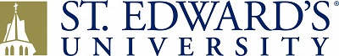

Memorandum of Agreement for Digital Rights

I, _________________________________, affirm that I remain the owner of the property described on this paper and unconditionally give St. Edward’s University, its successors and assigns, permission to digitize, host, and publish online, the following item(s) in perpetuity:
__________________________________________________________________
__________________________________________________________________
__________________________________________________________________

I understand that materials hosted by St. Edward’s University are freely accessible for use in research, teaching (including distribution to classes), and private study. For these uses people may use materials from our St. Edward’s website without prior permission, on the condition that they properly cite and attribute the source of materials on all copies.

I understand that reproduction of these oral history materials for publication, broadcast, or commercial use requires my written permission.

_____________________________________________ _____________________
Signed Date

Address_______________________________________________
_________________________________________________
_________________________________________________

Phone_________________________________________________

